“AIR QUALITY ANALYSIS AND POLLUTION PREDICTION“

24ADI204 - DATA SCIENCE AND VISUALISATION
Submitted by

AJAYSELVAKUMAR K - 25BAD004 ASHWINKUMAR N - 25BAD015 HARISH K - 25BAD033 LOGAPRADEEP N D - 25BAD050 ANUSH ADITHIYA D- 25BAD502
in partial fulfilment for the award of the degree of

BACHELOR OF TECHNOLOGY
IN

ARTIFICIAL INTELLIGENCE AND DATA SCIENCE


KUMARAGURU COLLEGE OF TECHNOLOGY
(An Autonomous Institution affiliated to Anna University, Chennai)

Post Box No: 2034, Coimbatore - 641049

NOVEMBER 2026

BONAFIDE CERTIFICATE

Certified that this project report “AIR QUALITY ANALYSIS AND POLLUTION PREDICTION” is the Bonafide work of “AJAYSELVAKUMAR K - 25BAD004, ASHWINKUMAR N - 25BAD015, HARISH K - 25BAD033,

LOGAPRADEEP N D - 25BAD050, ANUSH ADITHIYA D - 25BAD502” who carried
out the project work under my supervision.

SIGNATURE SIGNATURE

Dr. Sudharson D
HEAD OF THE DEPARTMENT
Department of Artificial Intelligence and Data Science,
Kumaraguru College of Technology, Coimbatore – 641049.
Ms. Shriaarthy E
SUPERVISOR
Department of Artificial Intelligence and Data Science,
Kumaraguru College of Technology, Coimbatore – 641049.

The candidates with college register number 25BAD004, 25BAD015, 25BAD033, 25BAD050, 25BAD502 were examined in the Project Viva-Voce examination held on 04/11/2026

Internal Examiner External Examiner


DECLARATION
I affirm that the project work titled “AIR QUALITY ANALYSIS AND POLLUTION PREDICTION” being submitted in partial fulfillment for the award of B. TECH Artificial Intelligence and Data Science is the original work carried out by us. It has not formed the part of any other project work submitted for the award of any degree or diploma,
either in this or any other University.


AJAYSELVAKUMAR K - 25BAD004


ASHWINKUMAR N - 25BAD015

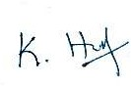
HARISH K - 25BAD033


LOGAPRADEEP N D - 25BAD050


ANUSH ADITHIYA D - 25BAD502

I certify that the declaration made above by the candidates is true.
Ms. Shriaarthy E

Assistant Professor,

Department of Artificial Intelligence and Data Science, Kumaraguru College of Technology,
Coimbatore – 641049.

ABSTRACT
This project analyses daily air-quality measurements collected across Indian cities. The work follows a complete analytical sequence: initial dataset exploration, data-quality assessment, missing-value treatment, outlier detection and handling, exploratory data analysis, feature engineering, feature selection, dimensionality reduction and interactive dashboard development. Python-based notebooks document the data preparation and analytical stages, while Microsoft Power BI presents the resulting information through an interactive report.
The integrated workflow uses 29,531 observations and 16 original columns covering 26 cities from 1 January 2015 to 1 July 2020. The raw dataset contains 88,488 missing entries and no exact duplicate rows. The cleaning stage removes Xylene due to high missingness, applies median-based imputation, investigates and caps selected outliers, and creates a cleaned dataset with 29,531 rows and 15 columns. Feature engineering creates separate transformed and standardized features, encodes City and AQI_Bucket, and groups AQI into six categories. Correlation-based feature selection removes NOx, and PCA creates a nine-component representation that retains 97.25% of total variance. The Power BI dashboard combines KPI cards, time trends, pollutant comparisons, AQI category views, geographic mapping and interactive filters.

REPORT ORGANISATION
- Week 2 – Know Your Data
- Week 3 – The Cleaning Sprint
- Week 4 – EDA Deep Dive
- Week 6 – Feature Engineering
- Week 7 – Feature Selection and PCA
- Week 8 – Interactive Dashboard Development
- Overall project outcome and conclusion

PROJECT BACKGROUND
Air quality changes with pollutant emissions, weather conditions, location and time. The Air Quality Index (AQI) provides a numerical and categorical representation of air quality. This project studies AQI alongside pollutant measurements such as PM2.5, PM10, nitrogen oxides, ammonia, carbon monoxide, sulphur dioxide, ozone, benzene and toluene. The analysis compares observations across cities and dates and prepares the data for clear visual interpretation.

PROJECT OBJECTIVES
- Understand the structure, coverage and quality of the Indian city-level air-quality dataset.
- Identify missing data and apply suitable feature removal or imputation techniques.
- Detect unusual pollutant and AQI values with statistical and visual methods.
- Explore distributions, city differences and pollutant relationships through charts.
- Transform and scale numerical features and encode categorical variables.
- Select relevant features and reduce dimensionality while preserving information.
- Present air-quality indicators and comparisons in an interactive Power BI dashboard.

DATASET AND SOFTWARE
The project uses city_day.csv, a daily air-quality dataset containing City, Date, pollutant concentrations, AQI and AQI_Bucket. The notebooks use Python with Pandas and NumPy for data handling, Matplotlib and Seaborn for visualisation, SciPy for statistical calculations, and scikit-learn for scaling, encoding, feature selection and PCA. Microsoft Power BI provides the dashboard environment.
Dataset source: Kaggle – Air Quality Data in India (https://www.kaggle.com/datasets/rohanrao/air-quality-data-in-india).

WEEK 2 – KNOW YOUR DATA
Week 2 established the first understanding of the dataset. We inspected its rows, columns, data types, city coverage, date range, missing values, duplicate records and AQI categories.

Loading the dataset
Step 1 – Import libraries. We imported Pandas to load and inspect tabular data and NumPy to support numerical operations.
Step 2 – Read the CSV file. We loaded city_day.csv into a Pandas DataFrame. The DataFrame provided a structured view of daily air-quality observations.
Step 3 – Preview records. We used head() to inspect the first five records and tail() to inspect the final five records. This helped verify the column layout and the type of values stored in each field.

Structure and feature inspection
Step 4 – Inspect DataFrame information. We used info() to review the number of records, column names, non-null counts and data types.
Step 5 – Identify numerical variables. We identified 13 numerical features: PM2.5, PM10, NO, NO2, NOx, NH3, CO, SO2, O3, Benzene, Toluene, Xylene and AQI.
Step 6 – Identify descriptive variables. We identified City, Date and AQI_Bucket as the three object-type fields. City identifies the observation location, Date identifies the observation day, and AQI_Bucket stores the AQI category.
The standalone Week 2 notebook reports 11,693 rows and 16 columns. It identifies 11 cities and a date range from 1 January 2015 to 1 July 2020.

Initial data-quality checks
Step 7 – Count missing values. We used isnull().sum() to calculate missing entries in each column. The notebook reports 29,796 missing values across the Week 2 dataset.
Step 8 – Check duplicate records. We used duplicated().sum() to identify exact duplicate rows. The output reports zero duplicate rows.

Step 9 – Review city coverage. We extracted unique city names from the City column, sorted them and counted the locations. The Week 2 notebook lists Ahmedabad, Aizawl, Amaravati, Amritsar, Bengaluru, Bhopal, Brajrajnagar, Chandigarh, Chennai, Coimbatore and Delhi.
Step 10 – Review AQI categories. We used value_counts(dropna=False) on AQI_Bucket so the output included missing categories as well as available labels.
The category counts in the Week 2 notebook are Satisfactory: 3,748; Moderate: 3,265; Poor: 1,077; Severe: 853; Very Poor: 769; Good: 581; and missing category values: 1,400.

Week 2 outcome
The initial exploration described the data structure and highlighted missing measurements in pollutant and AQI-related columns. The duplicate check found no exact duplicate rows in the Week 2 extract. These results provided the initial quality profile used to plan the cleaning activity.
The integrated full-project workflow used in Weeks 3–7 contains a later dataset snapshot with 29,531 rows, 16 columns and 26 cities. Week 3 onwards uses this integrated dataset; the Week 2 standalone notebook retains its own recorded 11,693-row output.
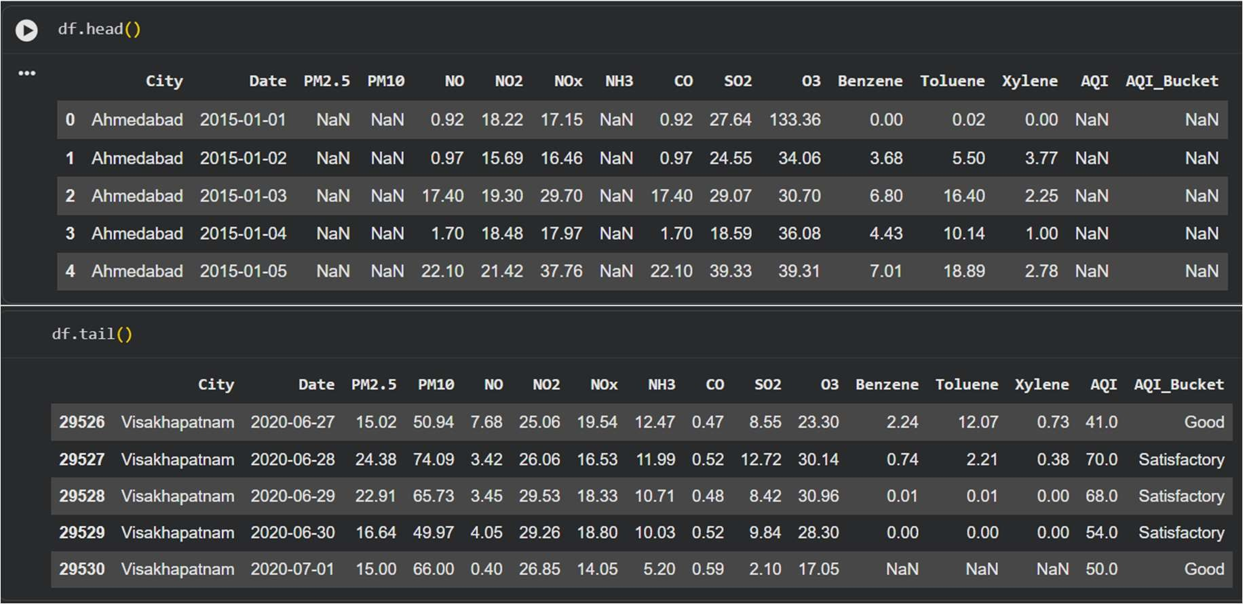
SCREENSHOT 2.1 – DATASET PREVIEW AND STRUCTURE

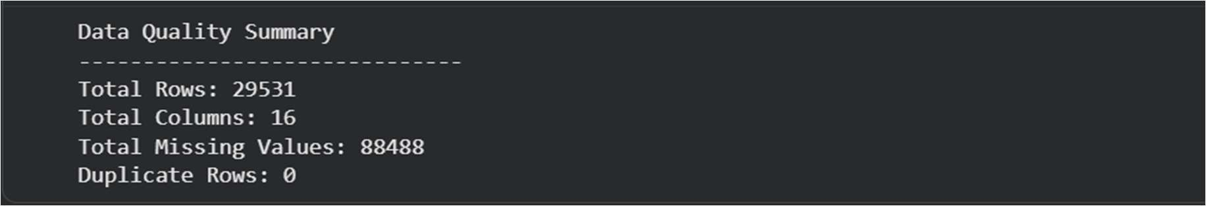
SCREENSHOT 2.2 – MISSING VALUES, DUPLICATES AND CITIES

WEEK 3 – THE CLEANING SPRINT
Week 3 improved the quality of the integrated air-quality dataset. We created a separate working copy, treated missing values, investigated outliers and validated the final cleaned data.

Create a working dataset
Step 1 – Preserve the raw dataset. We copied the original DataFrame into df_clean. This allowed cleaning operations to take place on a separate working dataset.
Step 2 – Record the initial quality profile. The integrated dataset contained 29,531 rows, 16 columns, 88,488 missing values and zero duplicate rows. Missing values represented 18.73% of all entries.

Analyse missing values
Step 3 – Calculate missing counts and percentages. We calculated the number and percentage of missing values for every column using isnull().sum() and the column-wise missing-value proportion.
Step 4 – Identify high-missingness features. Xylene contained 18,109 missing values (61.32%), PM10 contained 11,140 (37.72%), and NH3 contained 10,328 (34.97%). AQI and AQI_Bucket each contained 4,681 missing entries.
Step 5 – Examine incomplete pollutants against AQI. We compared available pollutant and AQI pairs to understand the relationship in the observed records. The notebook reports correlations of 0.803 for PM10,
0.252 for NH3 and 0.166 for Xylene.

Apply missing-value treatment
Step 6 – Remove Xylene. We removed Xylene because 61.32% of its values were missing. This reduced the dataset from 16 columns to 15.
Step 7 – Impute PM10 and NH3 by city. We calculated the median separately for each city and used that city's median to fill missing values. When a city had no observed values for a pollutant, we used the overall median as a fallback.
Step 8 – Impute other numerical pollutant features. We applied median-based imputation to the remaining numerical pollutant columns as implemented in the notebook.
Step 9 – Treat missing AQI values. We used city-wise AQI medians and an overall median fallback to fill missing AQI measurements.
Step 10 – Recalculate AQI_Bucket. We derived the AQI category from the treated AQI values so the numerical AQI and its category remained consistent.
Step 11 – Verify imputation. We checked missing-value counts after treatment. The notebook reports zero remaining missing values.

Detect potential outliers
Step 12 – Visual inspection with boxplots. We generated boxplots for numerical pollutant features to observe medians, interquartile ranges, spread and potential extreme observations.

Step 13 – Apply the IQR method. We calculated Q1 and Q3, then calculated IQR = Q3 − Q1. The lower and upper detection limits use Q1 − 1.5 × IQR and Q3 + 1.5 × IQR. Values outside those limits were flagged as potential outliers.
The highest IQR outlier percentages reported include Toluene at 12.97%, SO2 at 10.78% and CO at 10.00%.
Step 14 – Apply Z-score detection. We calculated standardized scores for pollutant values and treated absolute Z-scores greater than 3 as potential outliers. The notebook reports 675 potential outliers in NO, 667 in PM10 and 659 in NOx.

Treat outliers and investigate extreme AQI
Step 15 – Apply IQR-based capping to selected pollutants. We restricted values outside the calculated IQR limits to the lower or upper boundary. Capping retained the dataset rows instead of deleting complete observations.
Step 16 – Compare boxplots after capping. We generated post-treatment boxplots to visually inspect how the capping operation changed the distributions.
Step 17 – Investigate AQI values above 500. We isolated records with AQI greater than 500 and grouped them by city and AQI category. The notebook found 543 records above 500 and a maximum AQI of 2,049.
Step 18 – Examine city-wise extreme values. Ahmedabad contributed 412 of the 543 records, while Delhi contributed 48. The notebook showed that all 543 values above 500 belonged to the Severe AQI category.
Step 19 – Apply AQI capping and validate category. The notebook calculated an IQR upper capping limit of 391, capped AQI at that limit and recalculated AQI_Bucket. The final AQI range was 13 to 391.

Final quality verification and saved output
Step 20 – Run final checks. We checked the dataset dimensions, missing values and duplicate rows after all treatment operations.
Step 21 – Save the cleaned dataset. We exported the cleaned DataFrame as city_day_cleaned.csv.
The final Week 3 output contains 29,531 rows and 15 columns, with zero missing values and zero duplicate rows. This dataset forms the input for the Week 4 exploratory analysis.
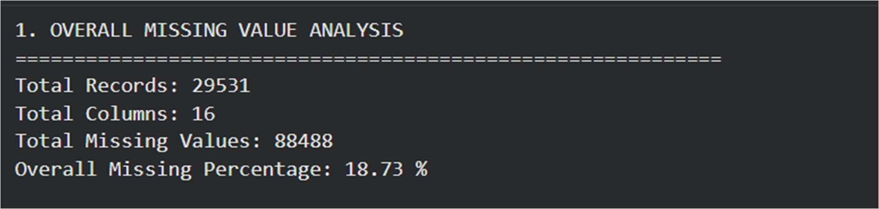
SCREENSHOT 3.1 – MISSING-VALUE ANALYSIS AND IMPUTATION

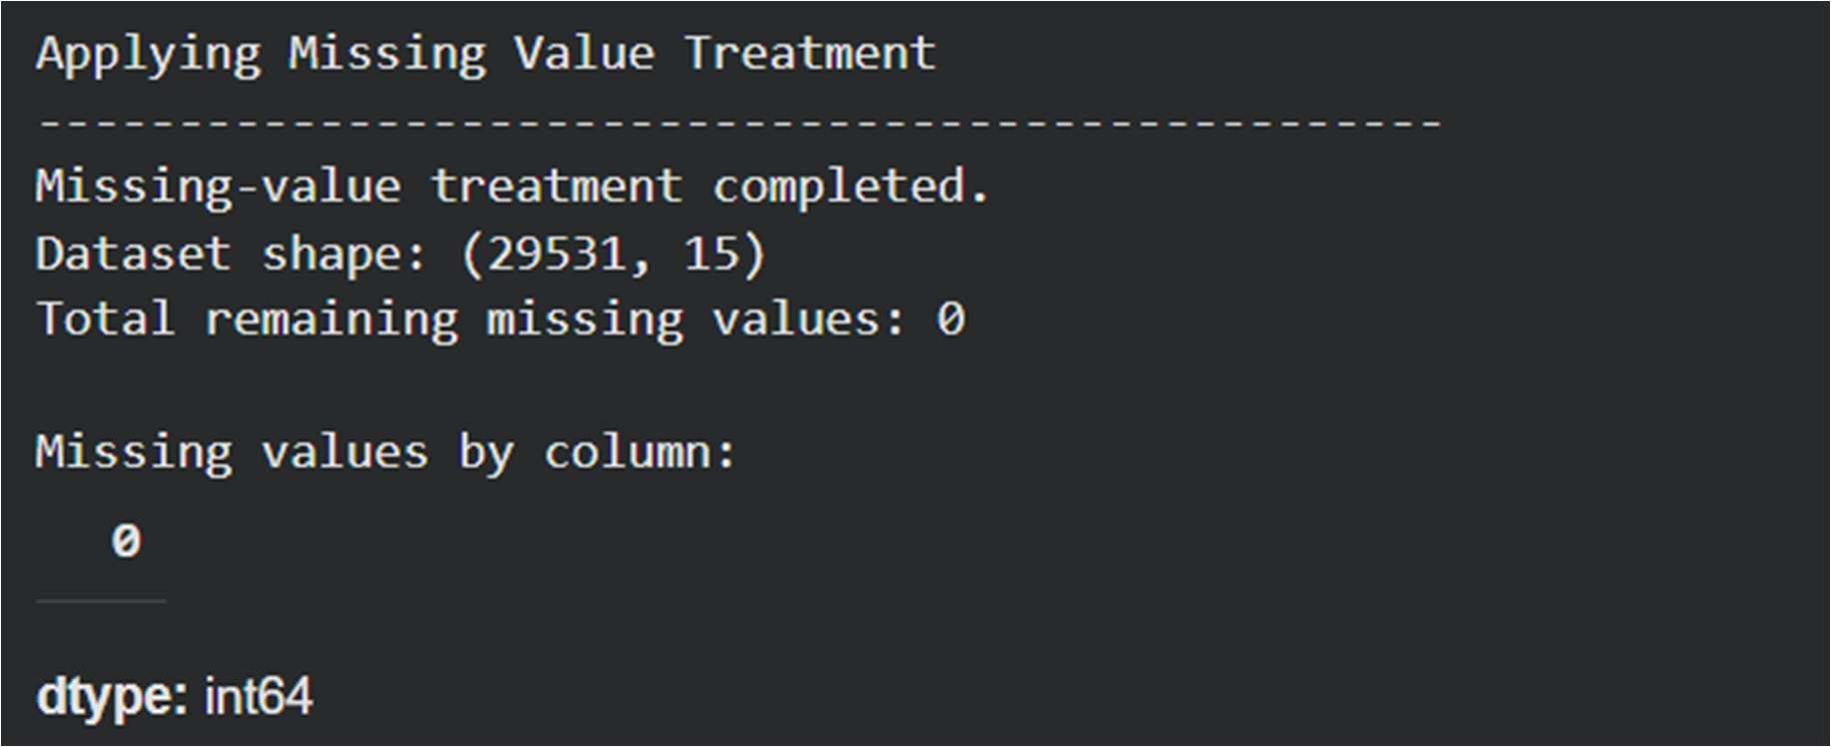

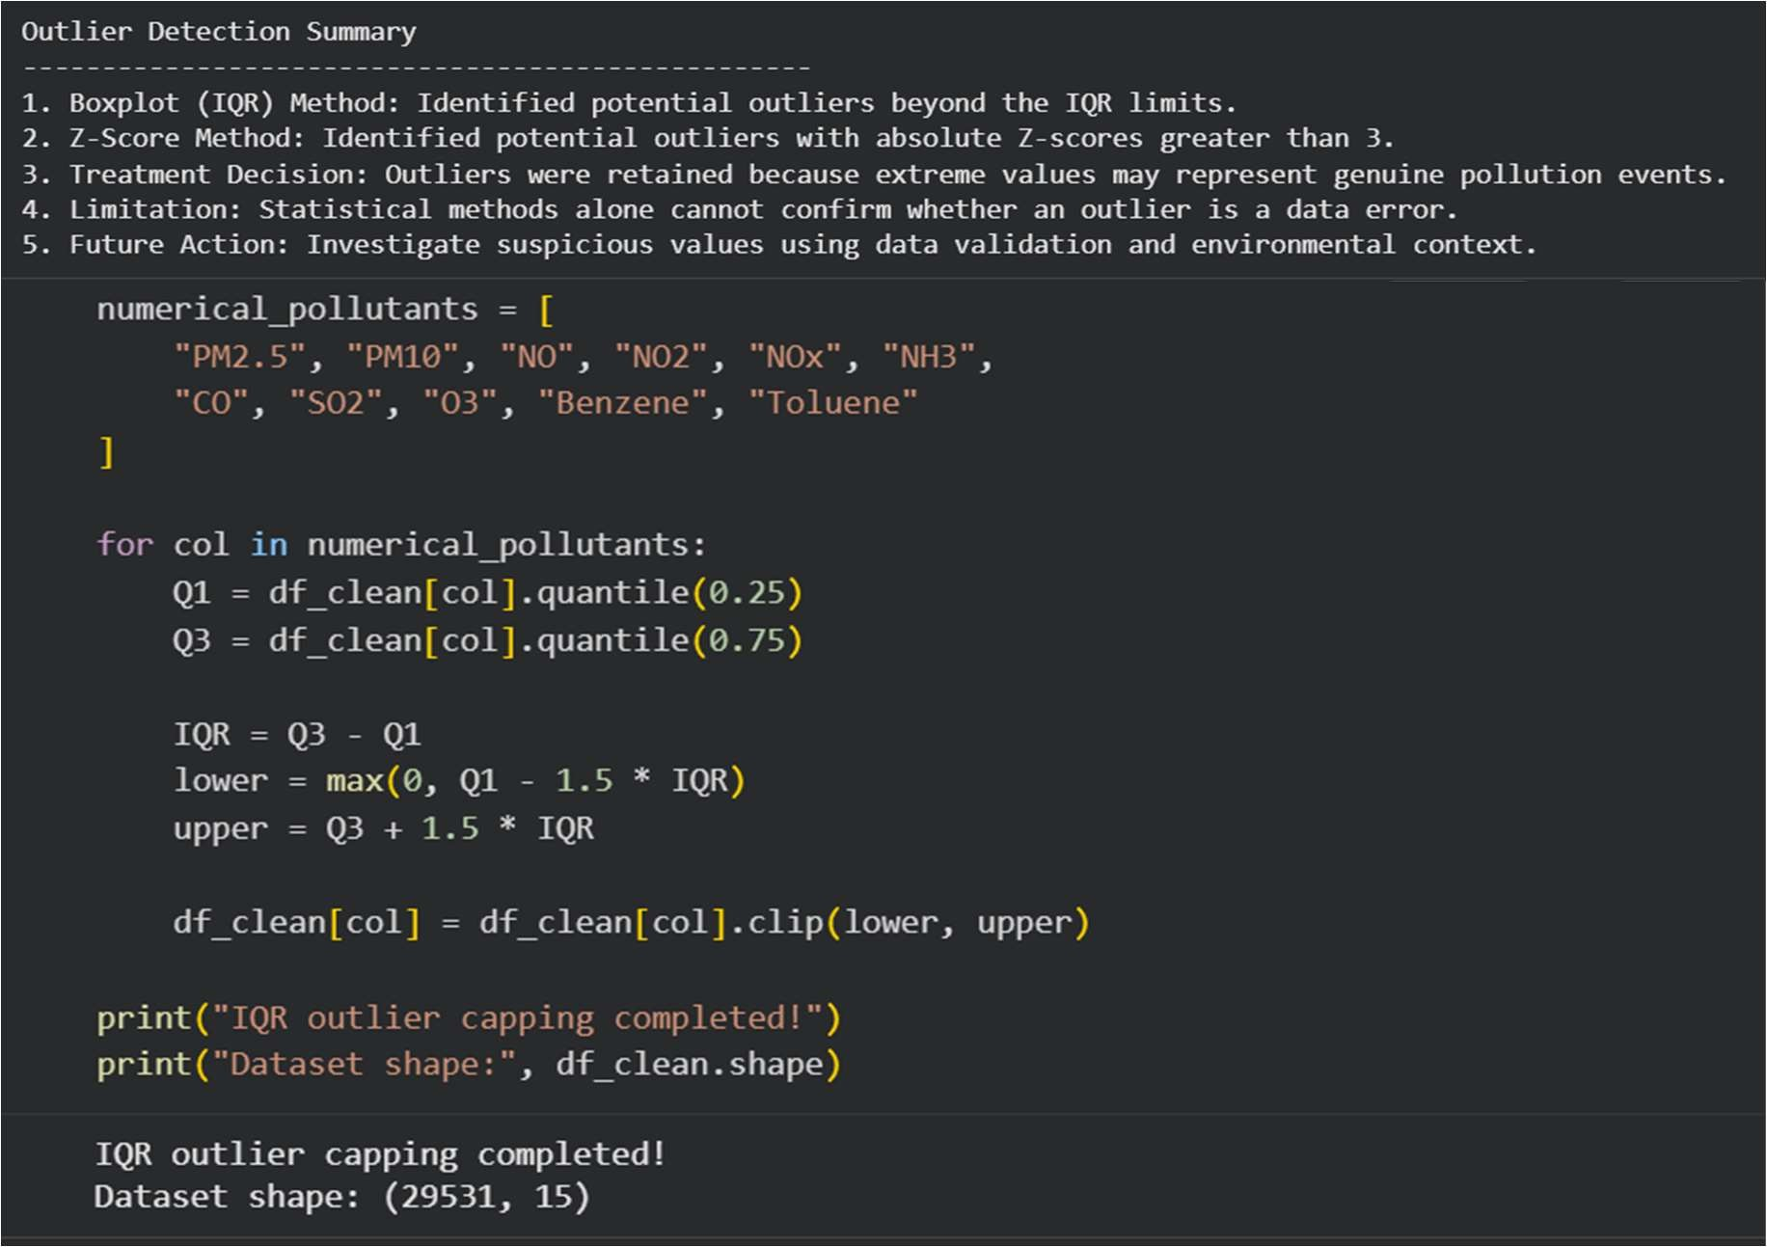
SCREENSHOT 3.2 – OUTLIER TREATMENT AND FINAL QUALITY CHECK

WEEK 4 – EDA DEEP DIVE
Week 4 used the cleaned dataset to study AQI and pollutant distributions, compare cities and explore relationships between pollutant concentrations and AQI.

Load and describe the cleaned data
Step 1 – Load the cleaned dataset. We used city_day_cleaned.csv as the source for exploratory analysis.
Step 2 – Verify dataset dimensions. The notebook confirmed 29,531 rows and 15 columns.
Step 3 – Generate descriptive statistics. We used describe() to calculate count, mean, standard deviation, minimum, maximum and quartiles for numerical features.
The reported mean AQI is 157.33, with a minimum of 13 and a maximum of 391. Mean PM2.5 is 58.50 and mean PM10 is 104.59.

Univariate analysis
Univariate analysis examines one variable at a time. We used the following charts to understand the distribution, spread and frequency of the main air-quality measurements.
Step 4 – AQI histogram. We plotted AQI values in histogram bins to examine how frequently observations occur across AQI ranges.
Step 5 – AQI boxplot. We used a boxplot to show the median, quartiles, spread and remaining extreme values in AQI.
Step 6 – AQI category distribution. We counted the six AQI categories and displayed their frequencies to compare category representation.
Step 7 – PM2.5 histogram. We plotted PM2.5 concentrations to inspect the distribution of fine particulate matter.
Step 8 – PM10 histogram. We plotted PM10 concentrations to inspect the distribution of particulate matter with a larger particle size.
Step 9 – Major pollutant boxplots. We compared PM2.5, PM10, NO, NO2, NOx, NH3, CO, SO2 and O3 using boxplots.
Step 10 – City-wise AQI distribution. We grouped AQI by City and used boxplots to compare city-level medians, spread and variation.

Bivariate analysis
Bivariate analysis examines two variables together. We used scatter plots and grouped charts to explore how AQI changes across pollutant measurements and locations.
Step 11 – PM2.5 versus AQI. We plotted PM2.5 on the horizontal axis and AQI on the vertical axis to inspect their association.

Step 12 – PM10 versus AQI. We created a second scatter plot to examine the relationship between PM10 and AQI.
Step 13 – CO groups versus average AQI. We divided CO concentrations into five groups using pd.cut(), calculated mean AQI for each group and displayed the results with a bar plot.
Step 14 – SO2 groups versus AQI. We grouped SO2 values using quantile-based bins and compared AQI distributions with a boxplot.
Step 15 – NO2 groups versus average AQI. We grouped NO2 values using quantile-based bins, calculated average AQI for each group and displayed the results as a line plot.
Step 16 – City versus average AQI. We grouped records by City, calculated mean AQI and displayed a city-wise bar chart.
Step 17 – AQI category versus PM2.5. We compared PM2.5 distributions across AQI_Bucket categories using a boxplot.

Week 4 outcome
The EDA stage created a set of descriptive statistics and visualisations for individual pollutant distributions, AQI categories, city-level differences and pollutant–AQI relationships. These plots provide a visual basis for understanding the cleaned data and communicating the patterns observed in the dataset.
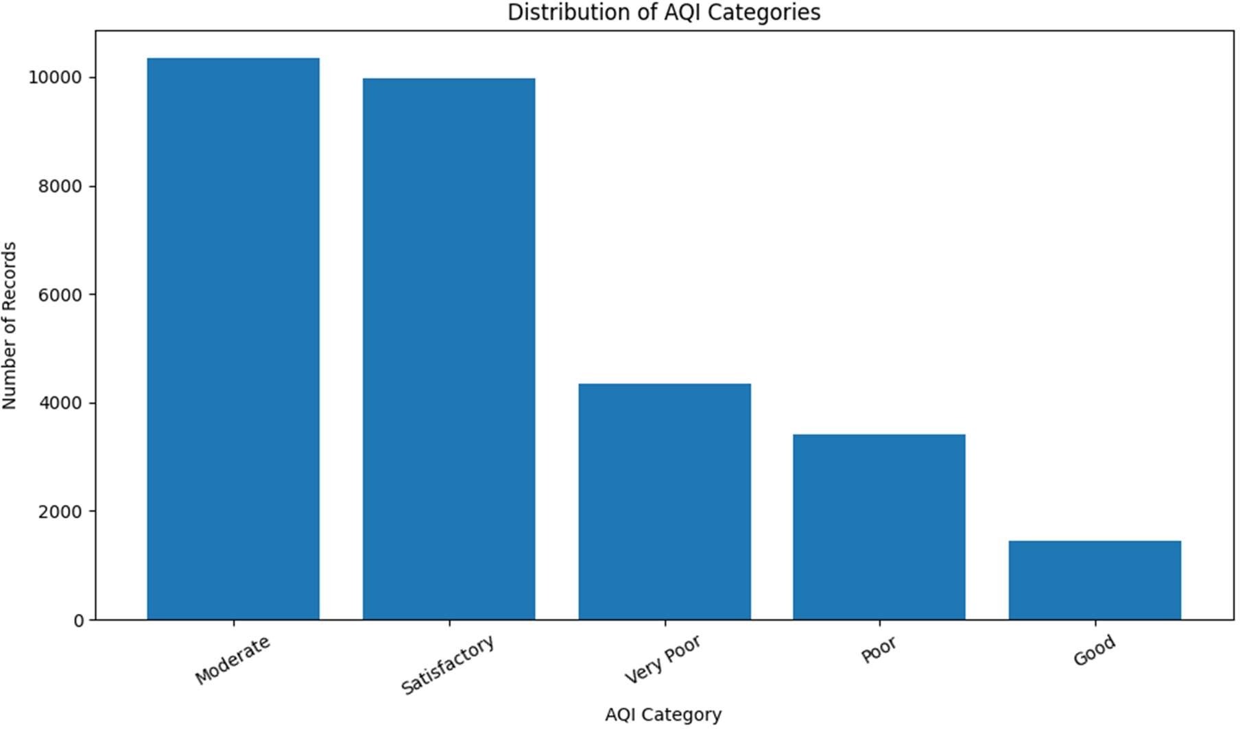
SCREENSHOT 4.1 – UNIVARIATE VISUALISATIONS

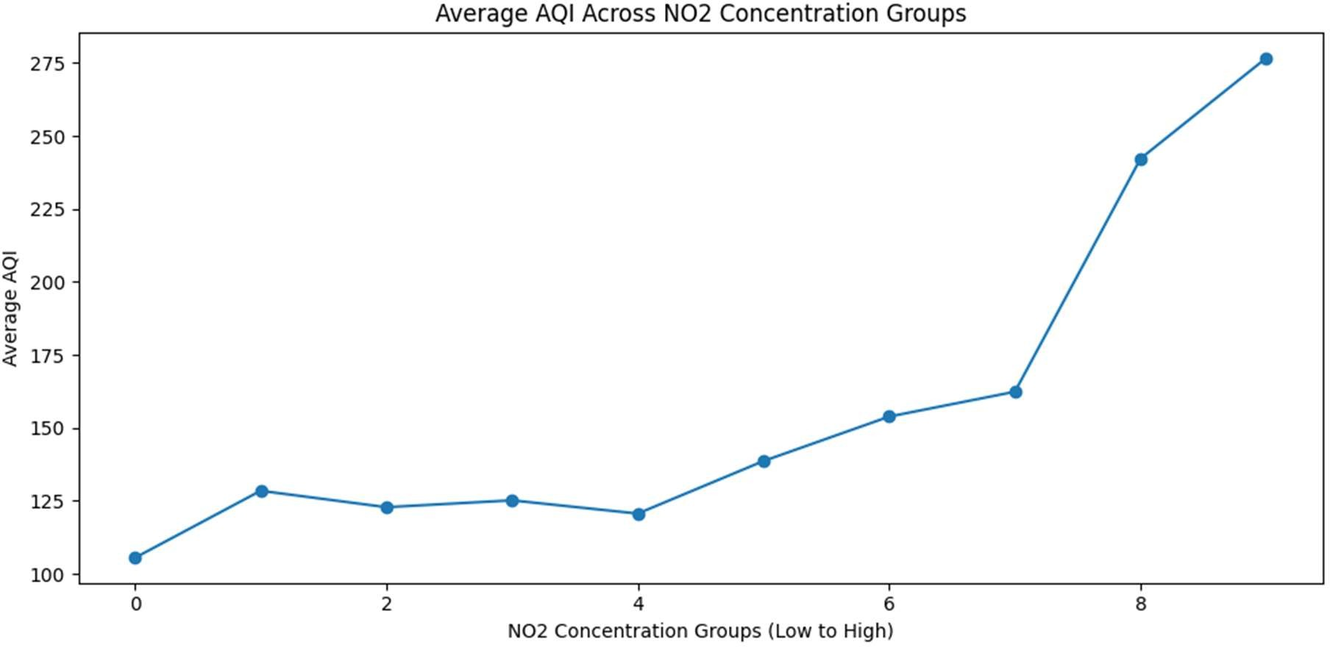
SCREENSHOT 4.2 – BIVARIATE VISUALISATIONS

WEEK 6 – FEATURE ENGINEERING
Week 6 prepared the pollutant measurements and categorical variables for further analysis by examining skewness, applying transformations, scaling features and encoding categories.

Select numerical pollutant features
Step 1 – Load the cleaned dataset. We used the cleaned 29,531-row dataset from the previous stage.
Step 2 – Select 11 pollutant columns. We selected PM2.5, PM10, NO, NO2, NOx, NH3, CO, SO2, O3, Benzene and Toluene for numerical feature analysis.

Measure skewness
Step 3 – Calculate skewness. We used the SciPy skewness function to measure the asymmetry of each pollutant distribution.
Step 4 – Interpret the initial distribution. All 11 pollutant features showed right skewness. PM2.5 had skewness 1.02, NO 1.19, Benzene 1.23 and Toluene 1.17.
A positive skewness value indicates a longer right tail. The initial results showed that pollutant measurements did not all follow symmetric distributions.

Apply and evaluate log transformation
Step 5 – Apply log1p(). We applied the log1p transformation to each selected pollutant feature. This transformation handles zero values more safely than taking a direct logarithm.
Step 6 – Preserve original columns. We stored transformed values in separate columns with a _log suffix, keeping the original pollutant measurements available for comparison.

Step 7 – Compare skewness before and after transformation. We calculated skewness again for the transformed columns and compared the two values for each pollutant.
Step 8 – Visualise the distribution change. We generated before-and-after histograms to inspect the effect of the transformation.
The notebook reports PM2.5 skewness changing from 1.02 to −0.30, NO from 1.19 to −0.22, CO from 0.91 to 0.19, and Toluene from 1.17 to 0.14. The notebook's effectiveness check identifies improvements for PM2.5, NO, CO, SO2, Benzene and Toluene; reduced skewness for NO2 and NH3; and no improvement for PM10, NOx and O3, which became more left-skewed.

Create standardized numerical features
Step 9 – Collect transformed columns. We selected the 11 _log columns and stored them in log_features. The resulting dataset contains 29,531 rows and 11 columns.
Step 10 – Apply StandardScaler. We used StandardScaler to transform the selected features to a common scale by centring values around their mean and scaling them by their standard deviation.
Step 11 – Verify scaling. We stored the scaled result in scaled_features and checked the feature means and standard deviations. The notebook reports a mean approximately equal to zero and standard deviation approximately equal to one.
Step 12 – Verify completeness. We checked missing values in the log-transformed and standardized feature datasets. Both contain zero missing values.

Encode categorical variables
Step 13 – Inspect categorical features. We examined City, Date and AQI_Bucket. The cleaned data contains 26 unique cities, 2,009 unique dates and five observed AQI_Bucket categories.
Step 14 – One-Hot Encode City. We used pd.get_dummies() to create 26 binary columns representing the cities. The resulting City-encoded dataset contains 29,531 rows and 26 columns.
Step 15 – Label Encode AQI_Bucket. We used LabelEncoder to convert the five observed AQI_Bucket categories into integer labels. The notebook mapping is Good = 0, Moderate = 1, Poor = 2, Satisfactory = 3 and Very Poor = 4. The encoded output remains separate from the main cleaned dataset.

AQI binning and discretisation
Step 16 – Define AQI intervals. We defined the bin boundaries as 0, 50, 100, 200, 300, 400 and infinity.
Step 17 – Assign AQI categories. We used pd.cut() to map numerical AQI values into Good, Satisfactory, Moderate, Poor, Very Poor and Severe categories.
Step 18 – Count the resulting categories. The notebook reports Moderate as the largest category with 8,829 records, followed by Satisfactory with 8,224 records.
The six AQI bins created during discretisation are distinct from the five observed categories in the cleaned AQI_Bucket column used for Label Encoding.

Week 6 outcome
Week 6 generated a log-transformed feature dataset of 29,531 × 11, a standardized feature dataset of 29,531 × 11 and a One-Hot Encoded City dataset of 29,531 × 26. The transformation and scaling checks reported zero missing values. These outputs document the feature-engineering work completed in this stage.
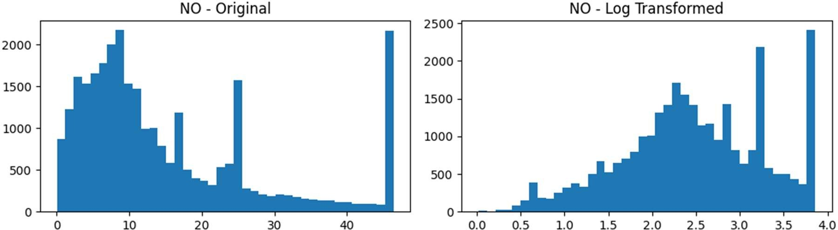
SCREENSHOT 6.1 – SKEWNESS AND LOG1P COMPARISON

WEEK 7 – FEATURE SELECTION AND PRINCIPAL COMPONENT ANALYSIS
Week 7 reduced redundancy among pollutant features and applied PCA to create a compact representation while retaining most of the variation in the data.

Prepare the PCA dataset
Step 1 – Select numerical pollutant features. We selected PM2.5, PM10, NO, NO2, NOx, NH3, CO, SO2, O3, Benzene and Toluene from the cleaned dataset.
Step 2 – Verify dataset completeness. The selected dataset contained 29,531 rows and 11 features. The missing-value check returned zero.

Apply variance thresholding
Step 3 – Set the variance threshold. We used VarianceThreshold with a threshold of 0.01 to identify features with very low variance.
Step 4 – Review selected features. All 11 pollutant features passed the threshold. Variance thresholding therefore retained every selected feature.

Correlation analysis and feature removal
Step 5 – Calculate the correlation matrix. We calculated pairwise correlations among pollutant features and examined the absolute correlation values.
Step 6 – Visualise correlations. We plotted a heatmap to identify strong relationships between pollutant measurements.

Step 7 – Apply the correlation threshold. We used 0.70 as the threshold for identifying highly correlated features.
Step 8 – Remove NOx. The feature-selection output identified NOx for removal. The number of pollutant features decreased from 11 to 10.
Step 9 – Verify the remaining feature set. The retained variables were PM2.5, PM10, NO, NO2, NH3, CO, SO2, O3, Benzene and Toluene. A second correlation check found no remaining pollutant pairs meeting the
0.70 threshold.

Standardize the selected features
Step 10 – Apply StandardScaler. We standardized the 10 retained pollutant features before PCA so that differences in measurement scale did not dominate the component calculation.
Step 11 – Verify the standardized data. The original and standardized datasets both contained 29,531 rows and 10 columns. The first standardized feature had a mean of approximately 0 and a standard deviation of 1.0.

Perform PCA and analyse component loadings
Step 12 – Fit PCA. We applied PCA to the standardized 10-feature dataset. The initial PCA output contained 29,531 observations and 10 principal components.
Step 13 – Examine component loadings. We inspected the component weights to understand the contribution of each original pollutant to the principal components.
The five largest absolute loadings reported for PC1 are NO2: 0.406, PM2.5: 0.382, PM10: 0.368, Toluene: 0.354 and NO: 0.324.

Explained variance and reduced dataset
Step 14 – Calculate explained variance ratios. We calculated the proportion of total variance explained by each principal component.
PC1 explains 35.56% of the variance and PC2 explains 13.23%. Together, the first two components explain 48.79%.
Step 15 – Calculate cumulative explained variance. We examined cumulative variance to identify the number of components needed to retain at least 95% of the information.
Step 16 – Select nine components. The notebook selected nine principal components. The final reduced dataset retains 97.25% of the total variance.
Step 17 – Visualise the first two components. We created a PC1-versus-PC2 scatter plot to display the observations in a two-dimensional component space.
Step 18 – Save the reduced dataset. We saved the nine-component representation as city_day_pca_reduced.csv.

Week 7 outcome
The feature-selection stage reduced the original 11 pollutant features to 10 by removing NOx. PCA then represented those 10 standardized features with nine principal components and retained 97.25% of total variance. The reduced output contains 29,531 rows and nine component columns.

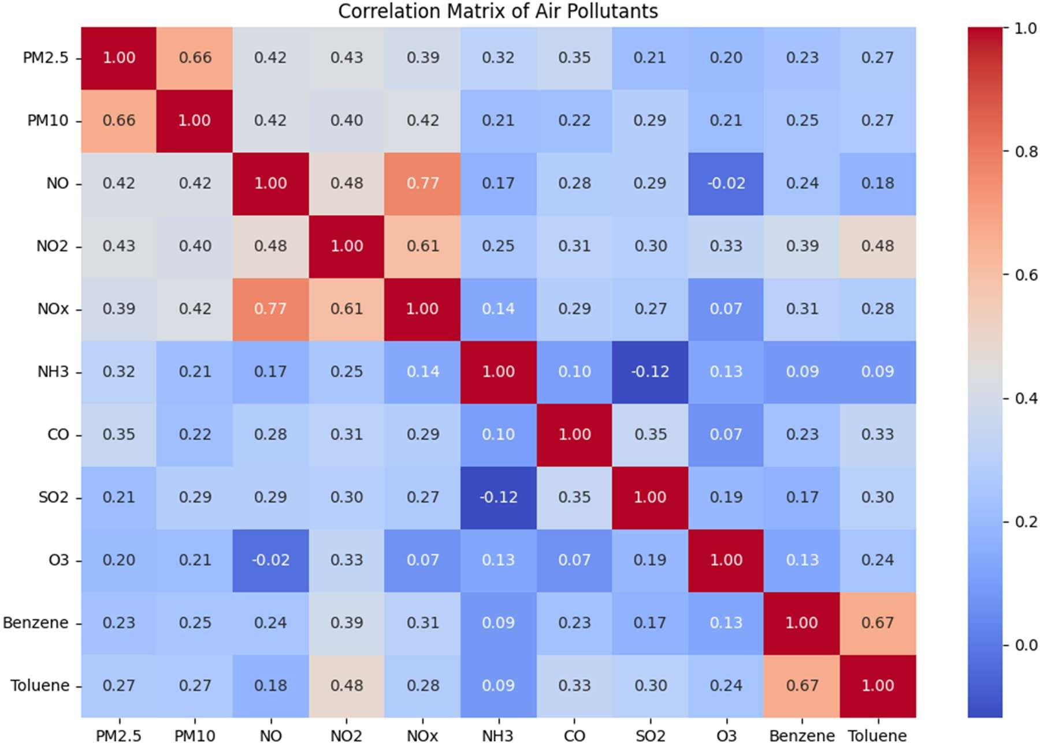
SCREENSHOT 7.1 – CORRELATION HEATMAP AND FEATURE SELECTION

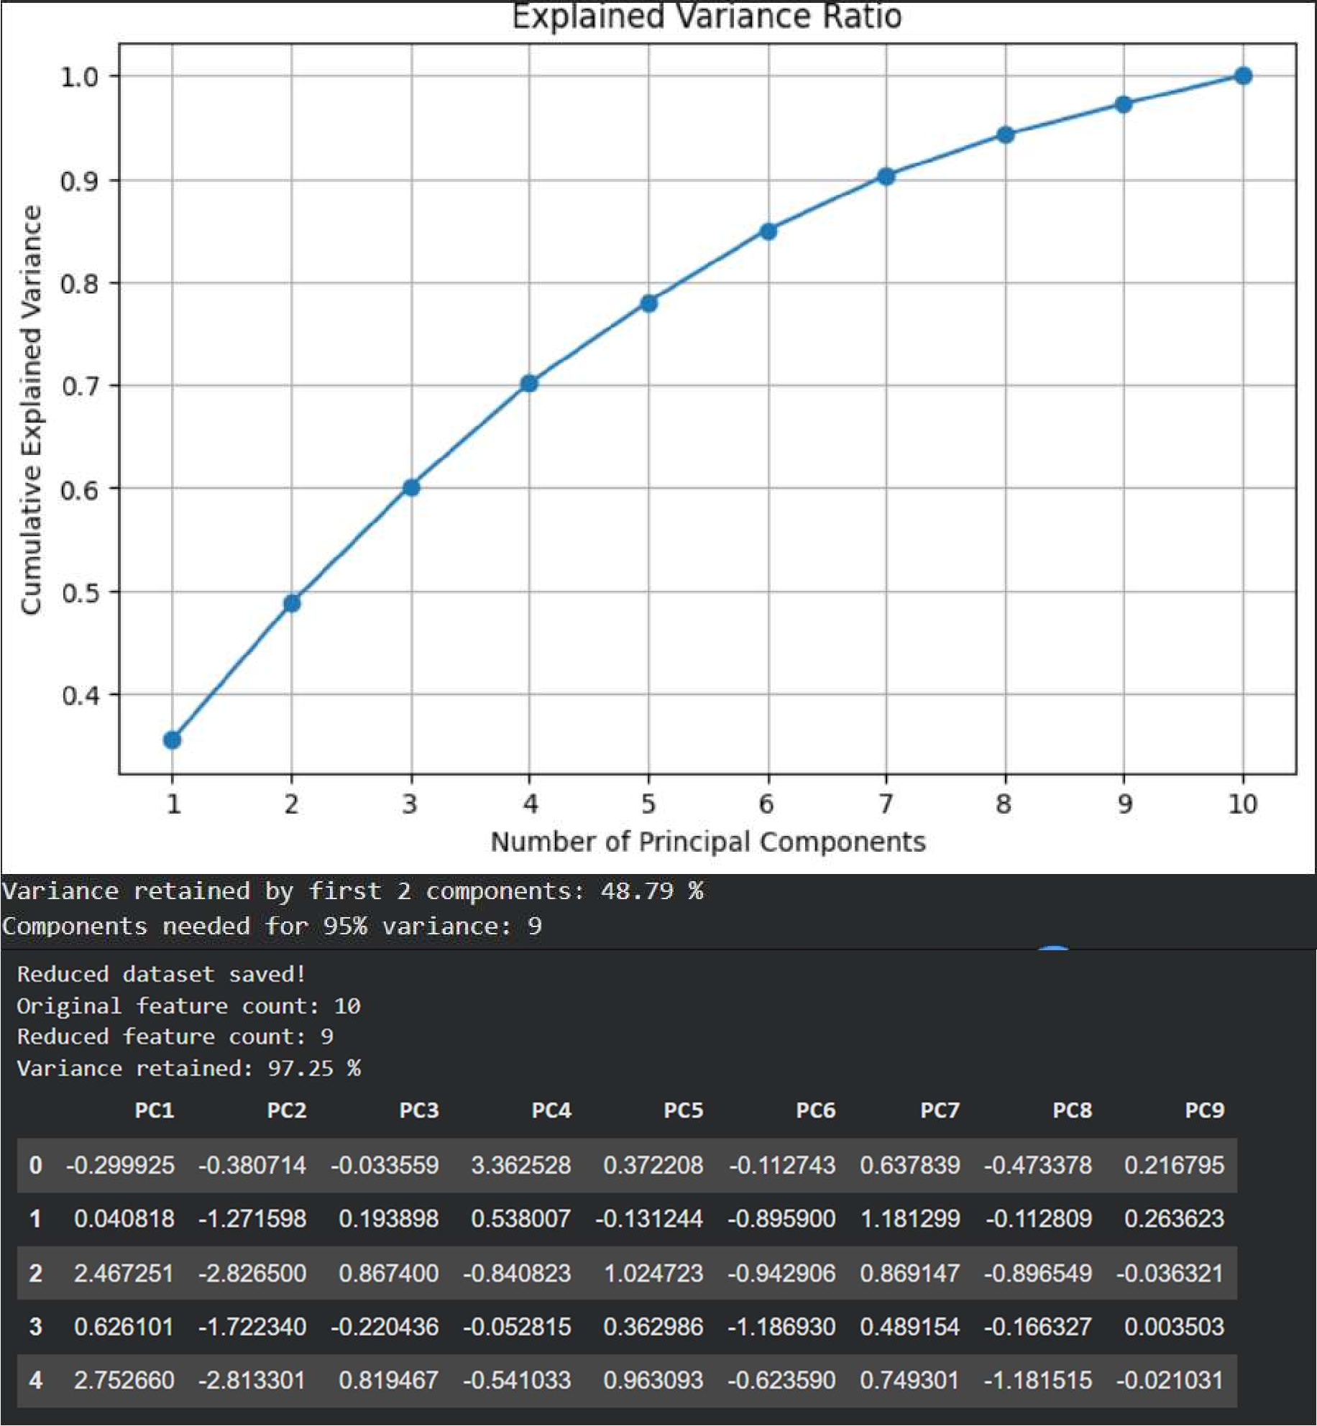
SCREENSHOT 7.2 – PCA EXPLAINED VARIANCE AND REDUCED DATASET

WEEK 8 – INTERACTIVE DASHBOARD DEVELOPMENT
Week 8 brought the air-quality analysis into an interactive Power BI report titled “India Air Quality Intelligence – A Data-Driven Analysis of Air Pollution Across Indian Cities.”

Dashboard setup and layout
Step 1 – Prepare the Power BI report. We created a Power BI report file and configured a 1920 × 1080 report canvas.
Step 2 – Apply the visual theme. We used the Fluent 2 theme to provide a consistent appearance across dashboard visuals.
Step 3 – Load geographic resources. The report package includes an India state-level GeoJSON resource for the geographic visual.
Step 4 – Arrange the report page. We organised the report as a single main dashboard page containing KPI cards, charts, a map and slicers.

Add KPI summary cards
Step 5 – Display key air-quality indicators. We added KPI cards for Total Cities, Average AQI, Minimum AQI and Maximum AQI. These cards provide an immediate summary of the dataset and current filter selection.

Build trend and comparison visuals
Step 6 – AQI trend line chart. We added a line chart to show AQI variation over time, with AQI_Bucket used as a category grouping.
Step 7 – Pollutant comparison column chart. We added a clustered column chart to compare PM2.5, PM10 and NO2 across cities.
Step 8 – AQI treemap. We added a treemap to show average AQI grouped by AQI_Bucket and City.
Step 9 – AQI category donut chart. We added a donut chart to display the distribution of AQI_Bucket categories using city counts.
Step 10 – Particulate comparison scatter chart. We added a scatter chart to compare PM2.5 and PM10 across cities and AQI categories.
Step 11 – NO versus AQI scatter chart. We added a second scatter chart to examine the relationship between NO and AQI across cities.
Step 12 – AQI gauge. We added a gauge visual to display AQI against the minimum and maximum AQI measures.

Add geographic and interactive elements
Step 13 – India state map. We added an India shape map using the state GeoJSON resource and AQI-related fields, including State, AQI_Bucket and Average AQI.

Step 14 – Add slicers. We added City, State and Date slicers so users can filter the dashboard by location and time.
Step 15 – Review the dashboard page. We arranged the visuals on the main report page to provide a combined view of AQI indicators, time trends, pollutant comparisons, category distribution and geographic patterns.

Dashboard outcome
The completed dashboard contains KPI cards, a line chart, clustered column chart, treemap, donut chart, two scatter charts, a gauge, an India state map and interactive slicers. It provides a single visual interface for exploring air-quality information across cities, states, dates, pollutant measurements and AQI categories.

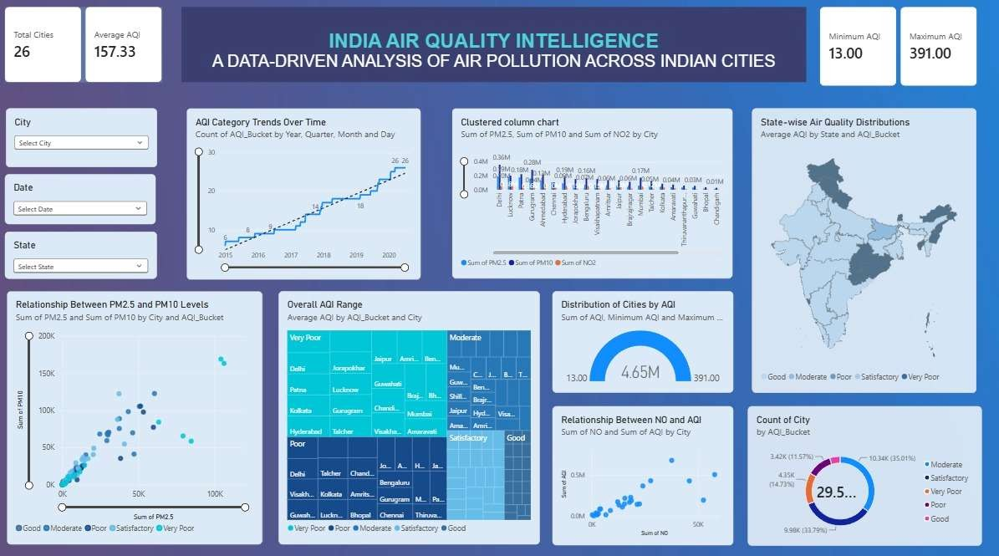
SCREENSHOT 8.1 – AQI ANALYSIS DASHBOARD

OVERALL PROJECT RESULTS
The project progressed through dataset exploration, data cleaning, exploratory analysis, feature engineering, feature selection, PCA and interactive dashboard development. The main numerical results from the integrated workflow are summarised below in narrative form.

Data preparation
The integrated dataset began with 29,531 rows and 16 columns. The initial quality check found 88,488 missing values and zero duplicate rows. Xylene was removed due to 61.32% missingness. Median-based imputation treated the incomplete pollutant and AQI fields, while AQI_Bucket was recalculated from treated AQI. IQR and Z-score methods identified potential outliers, and selected values were capped. The cleaned output contains 29,531 rows and 15 columns with no missing values and no duplicate rows.

Exploratory analysis
The EDA stage calculated descriptive statistics and produced histograms, boxplots, scatter plots, grouped bar and line charts, AQI category comparisons and city-level AQI visualisations. The cleaned data had a mean AQI of 157.33, a minimum AQI of 13 and a maximum AQI of 391. Mean PM2.5 was 58.50 and mean PM10 was 104.59.

Feature engineering and dimensionality reduction
Week 6 created 11 log-transformed pollutant features and 11 standardized pollutant features, each with 29,531 rows. City encoding created 26 binary columns. Week 7 retained 11 features after variance thresholding, removed NOx using the 0.70 correlation threshold, and applied PCA to the remaining 10 standardized features. Nine principal components retained 97.25% of the total variance.

Dashboard
The Power BI dashboard consolidated the project's analysis into one report page. It includes KPI summaries, AQI trends, pollutant comparisons, AQI category distribution, scatter plots, a gauge, an India state map and City, State and Date slicers.

CONCLUSION
The project completed the planned analytical sequence represented by Weeks 2, 3, 4, 6, 7 and 8. Initial exploration identified the structure and quality of the air-quality dataset. The cleaning process treated missing measurements, investigated unusual observations and produced a complete cleaned dataset. EDA described AQI and pollutant distributions and explored relationships across variables and cities. Feature engineering transformed and standardized pollutant measurements and encoded categorical information. Feature selection removed a highly correlated pollutant, and PCA reduced the selected feature space to nine components while retaining 97.25% of total variance. The Power BI dashboard presents the resulting indicators and analyses through multiple visual types and interactive filters.
Together, the notebooks, cleaned data, reduced PCA dataset and Power BI dashboard provide a documented workflow for analysing air quality across Indian cities.

PROJECT OUTPUTS
- city_day_cleaned.csv – cleaned air-quality dataset with 29,531 rows and 15 columns.
- city_day_pca_reduced.csv – reduced PCA dataset with 29,531 rows and nine principal components.
- Colab notebooks – integrated full project and weekly notebooks for Weeks 2, 3, 4, 6 and 7.
- Power BI report – interactive dashboard for air-quality indicators and comparisons.
- Weekly project reports and this detailed consolidated report.

